Semicircular Arc
# Source: AI Source: Provided by: [Data Path: Persons Table -> ID Column: 1, Name_En Column: Motasem Essam] -> From: [ChatGPT] on [7/25/2026]
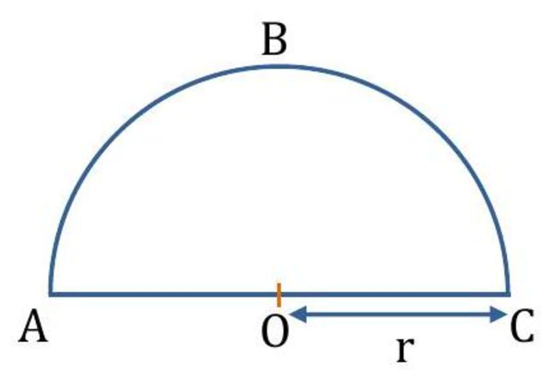
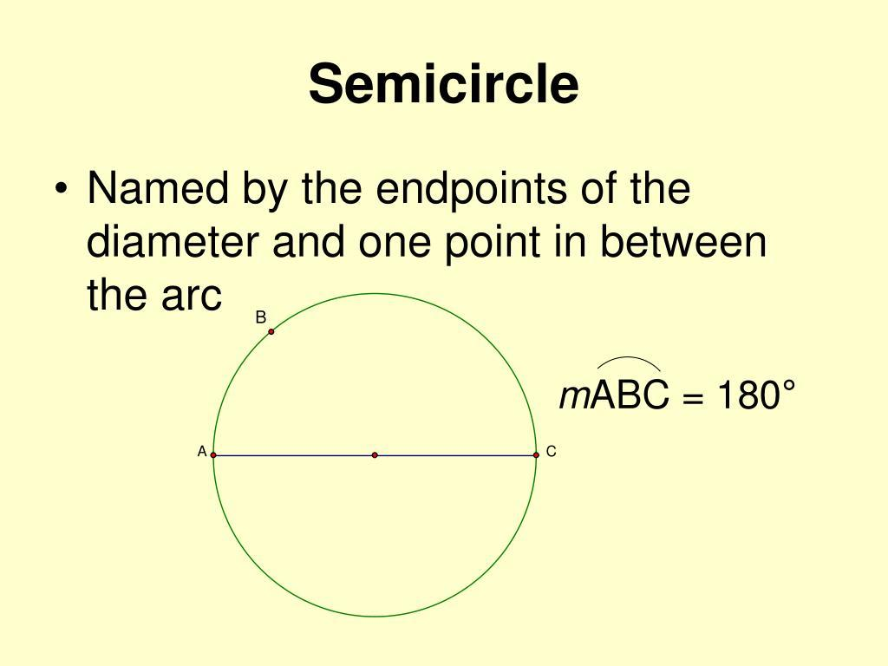
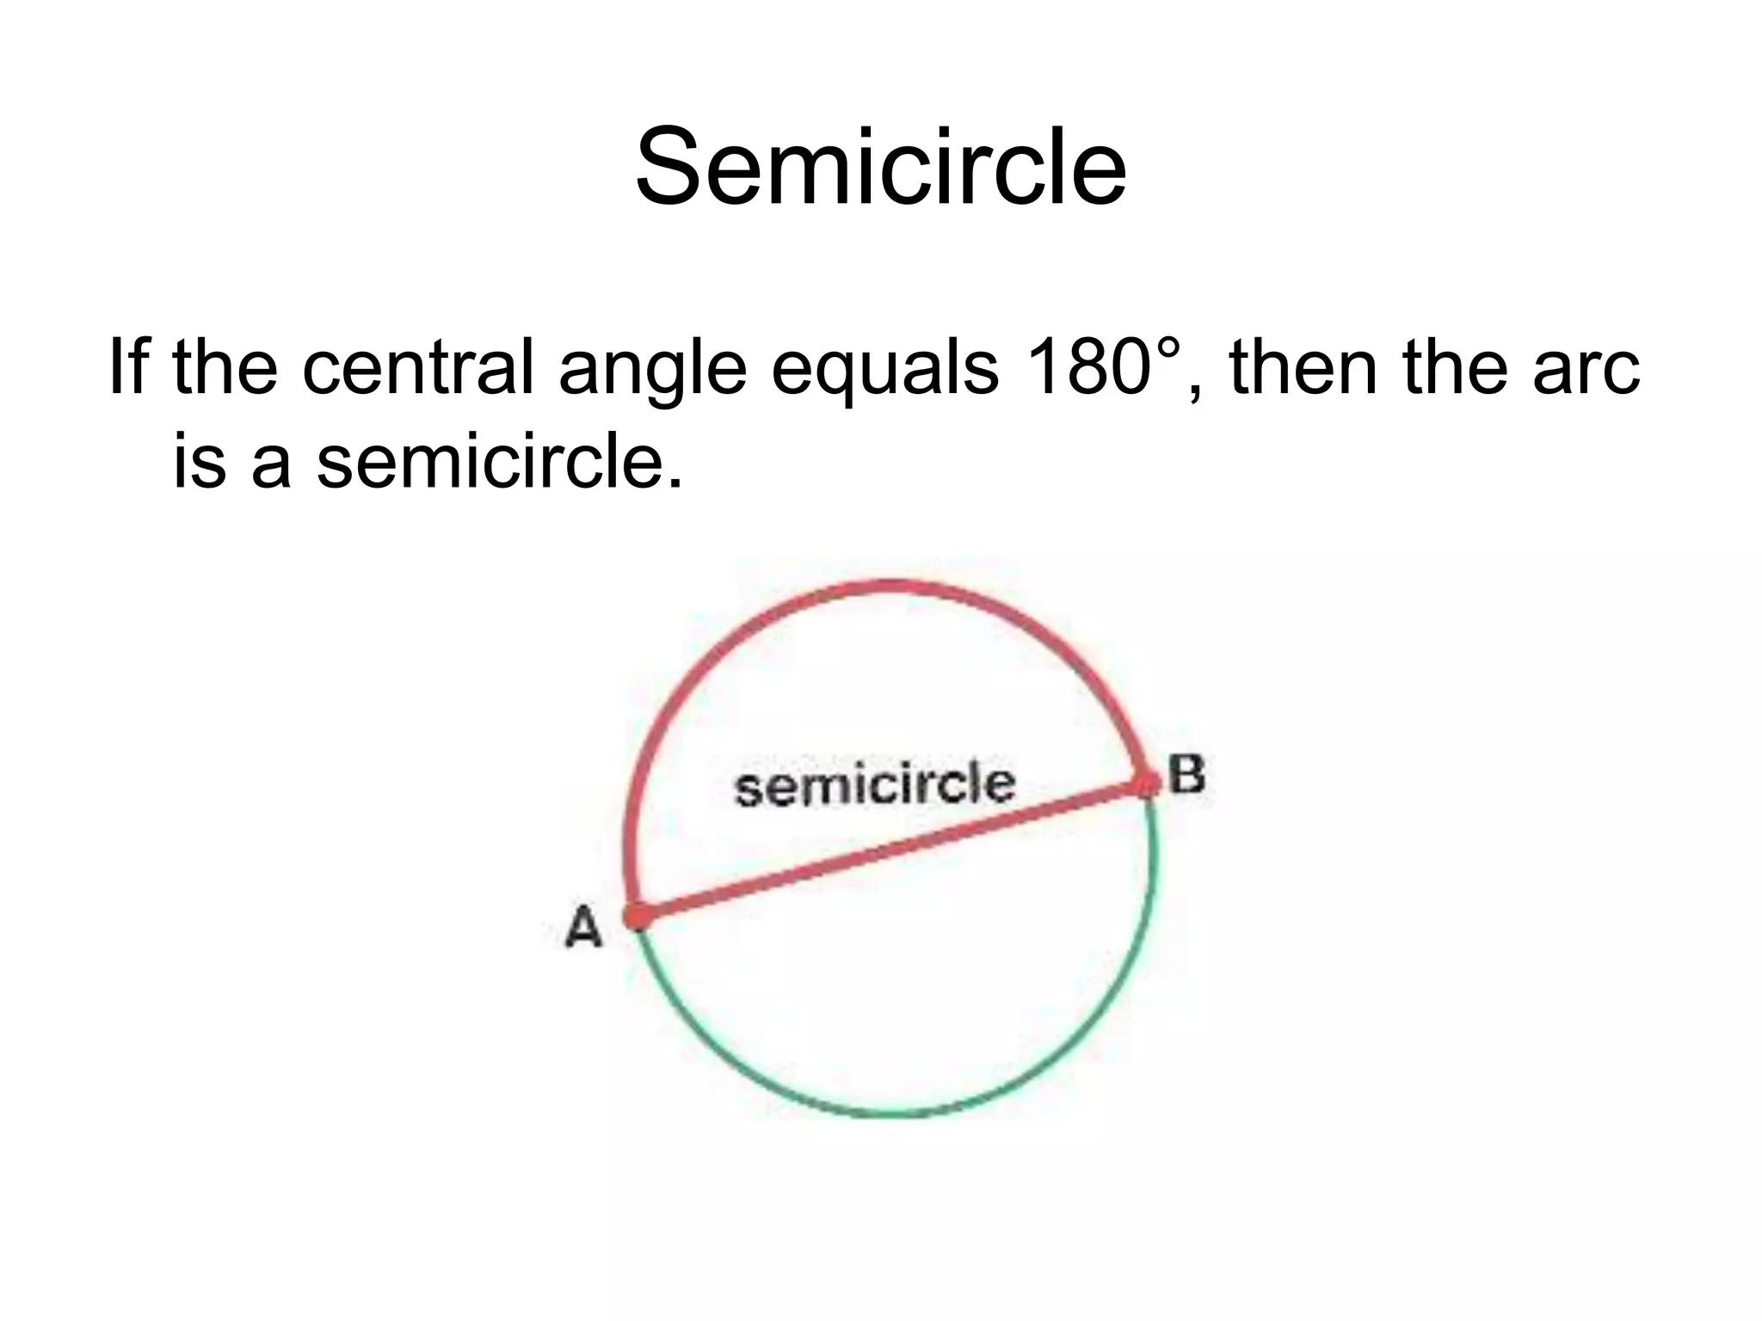
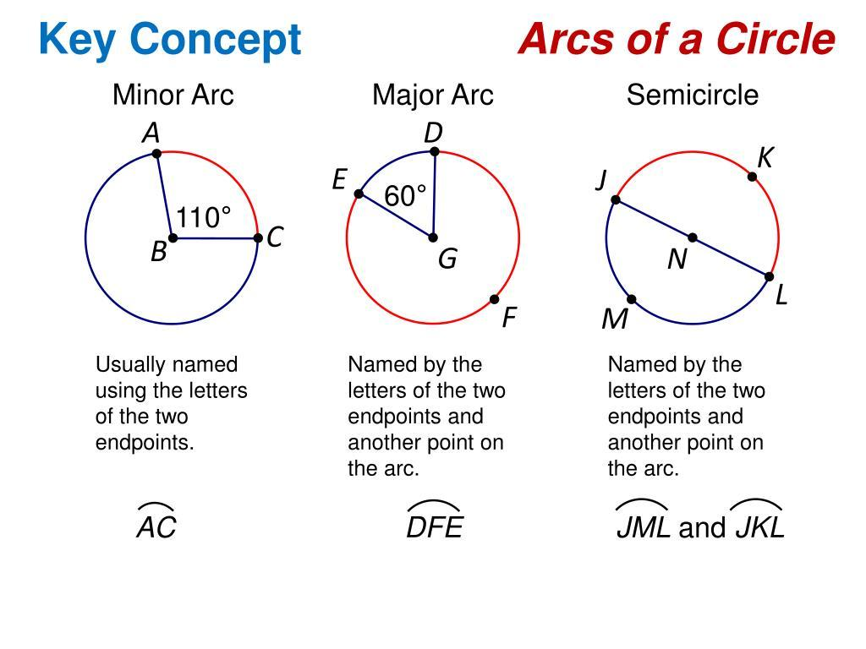
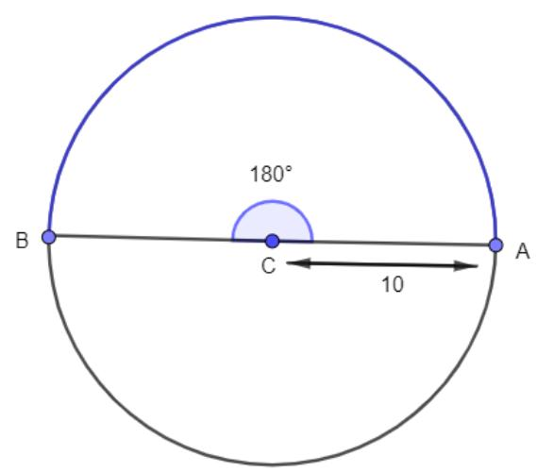
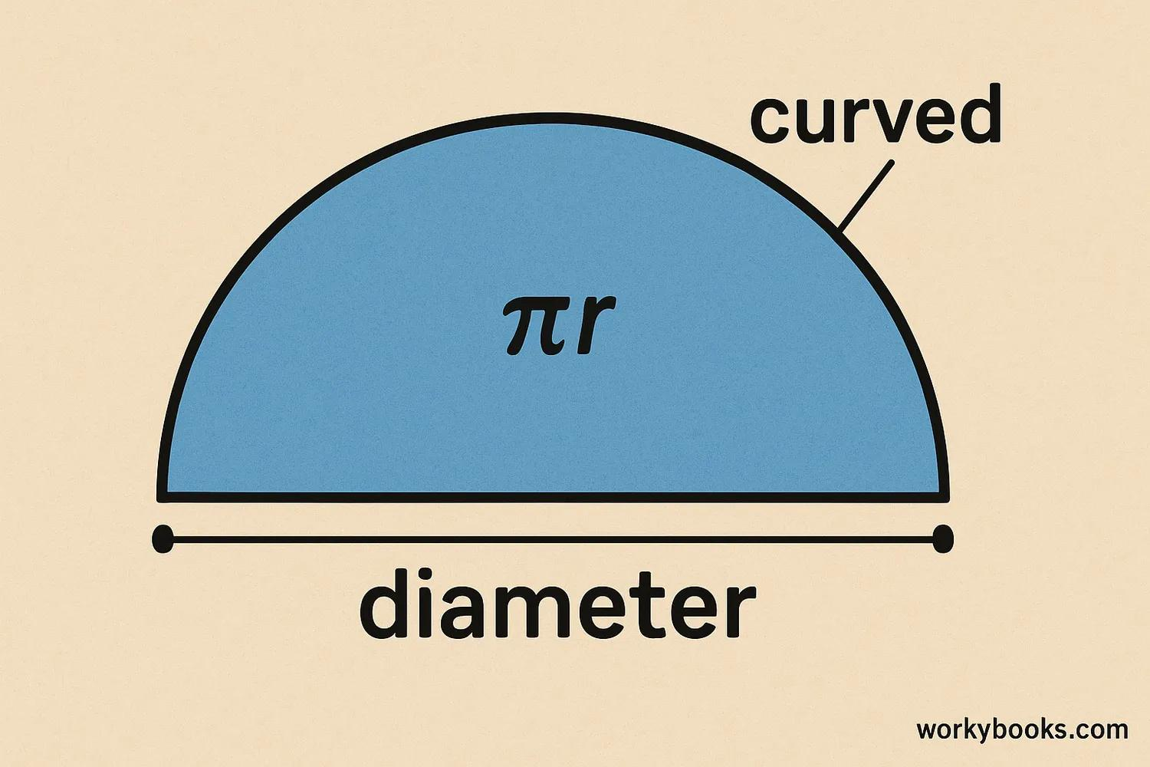

Definition
# Source: AI Source: Provided by: [Data Path: Persons Table -> ID Column: 1, Name_En Column: Motasem Essam] -> From: [ChatGPT] on [7/25/2026]
A Semicircular Arc is an arc of a circle that measures exactly ${180}^{∘}$.
It is formed when the two endpoints of an arc are the endpoints of a diameter. Therefore, a semicircular arc represents exactly half of the circumference of a circle.
If $A$and $B$are the endpoints of a diameter, the semicircular arc can be written as:
$$\hat{AB}$$
with:
$$m\left(\hat{AB}\right)={180}^{∘}$$

Fundamental Concept
# Source: AI Source: Provided by: [Data Path: Persons Table -> ID Column: 1, Name_En Column: Motasem Essam] -> From: [ChatGPT] on [7/25/2026]
A semicircular arc divides a circle's circumference into two equal arcs.
If $AB$is a diameter:
$$AB=2r$$
and the two arcs determined by $A$and $B$are both semicircular arcs.
Each has an arc measure of:
$${180}^{∘}$$
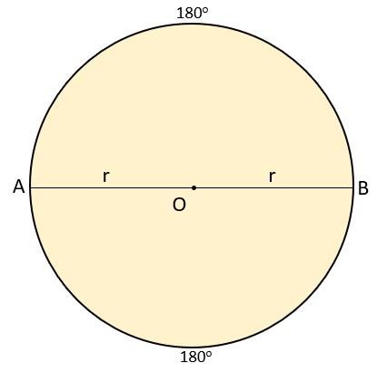
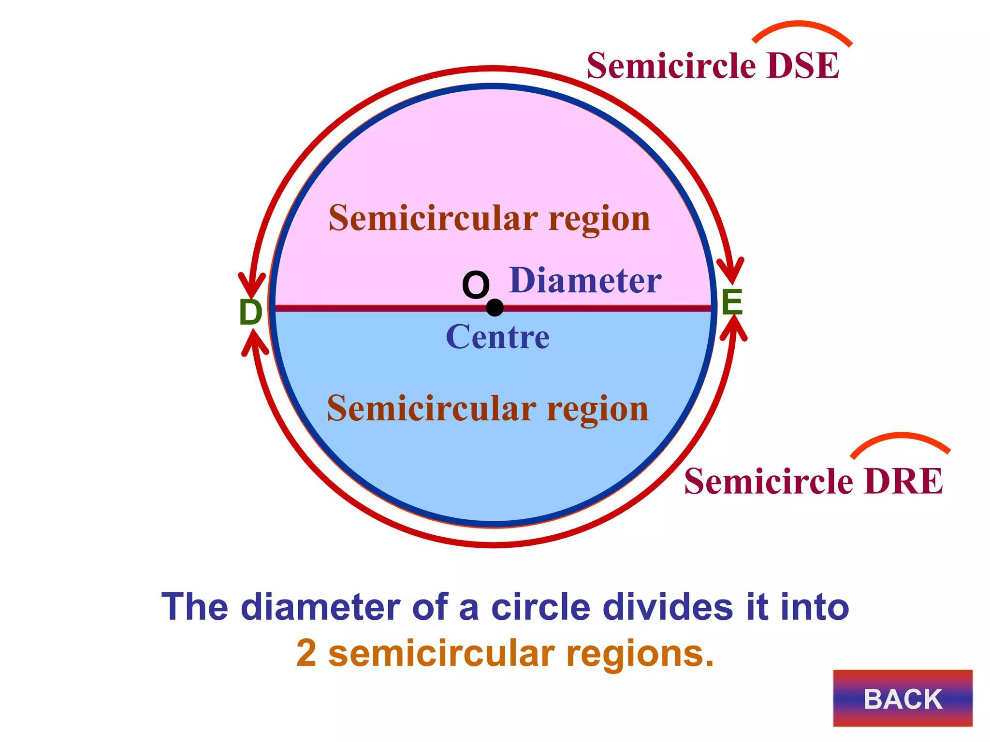
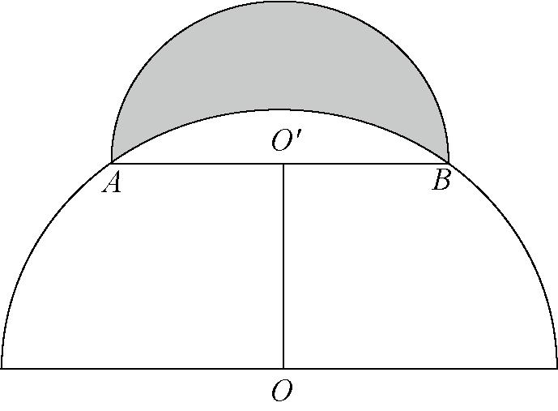
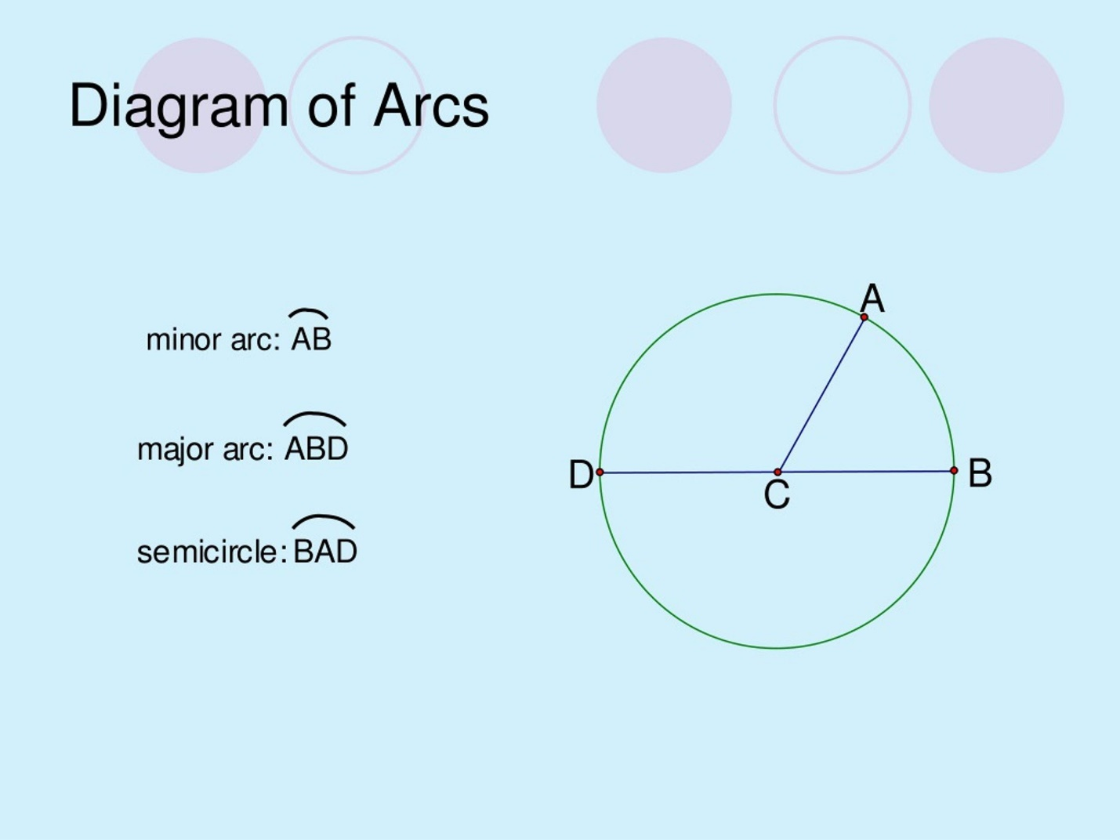
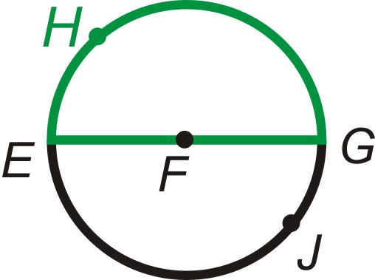

Fundamental Elements
# Source: AI Source: Provided by: [Data Path: Persons Table -> ID Column: 1, Name_En Column: Motasem Essam] -> From: [ChatGPT] on [7/25/2026]
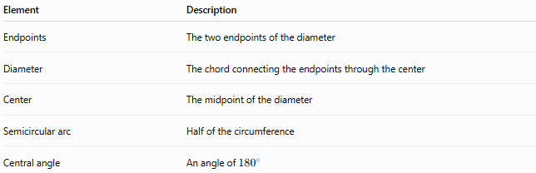
Element | Description
Endpoints | The two endpoints of the diameter
Diameter | The chord connecting the endpoints through the center
Center | The midpoint of the diameter
Semicircular arc | Half of the circumference
Central angle | An angle of ${180}^{∘}$

Mathematical Representation
# Source: AI Source: Provided by: [Data Path: Persons Table -> ID Column: 1, Name_En Column: Motasem Essam] -> From: [ChatGPT] on [7/25/2026]
For a semicircular arc:
$$m\left(\hat{AB}\right)={180}^{∘}$$
The corresponding central angle is:
$$m\left(∠AOB\right)={180}^{∘}$$
where $O$is the center.
Because the arc is half of the circumference, its length is:
$$L=\frac{1}{2}\left(2πr\right)$$
Therefore:
$$\boxed{L=πr}$$
Since $d=2r$, it can also be written as:
$$\boxed{L=\frac{πd}{2}}$$

Main Properties
# Source: AI Source: Provided by: [Data Path: Persons Table -> ID Column: 1, Name_En Column: Motasem Essam] -> From: [ChatGPT] on [7/25/2026]
- A semicircular arc measures exactly ${180}^{∘}$.
- It is exactly half of a circle's circumference.
- Its endpoints are the endpoints of a diameter.
- Its corresponding central angle measures ${180}^{∘}$.
- Its arc length is $πr$.
- Every diameter creates two semicircular arcs.
- The two semicircular arcs have equal lengths.
- A semicircular arc is neither a minor arc nor a major arc.

Example
# Source: AI Source: Provided by: [Data Path: Persons Table -> ID Column: 1, Name_En Column: Motasem Essam] -> From: [ChatGPT] on [7/25/2026]
A circle has radius:
$$r=8\text{ cm}$$
The length of a semicircular arc is:
$$L=πr \\ L=8π\text{ cm} \\ L≈25.13\text{ cm}$$
The arc measure is:
$${180}^{∘}$$

Semicircular Arc and Diameter
# Source: AI Source: Provided by: [Data Path: Persons Table -> ID Column: 1, Name_En Column: Motasem Essam] -> From: [ChatGPT] on [7/25/2026]
A semicircular arc and its diameter together form a semicircle.
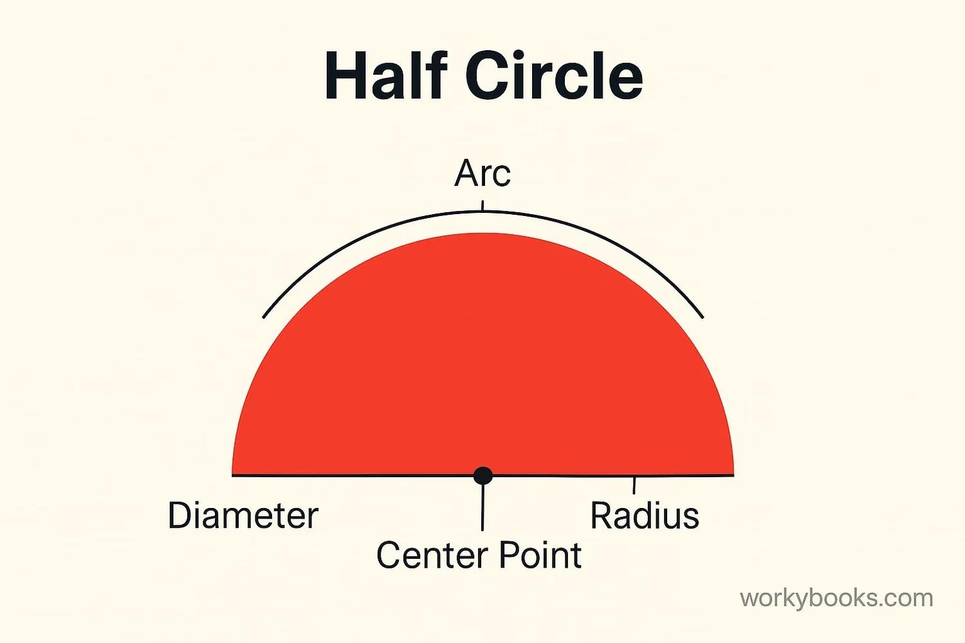
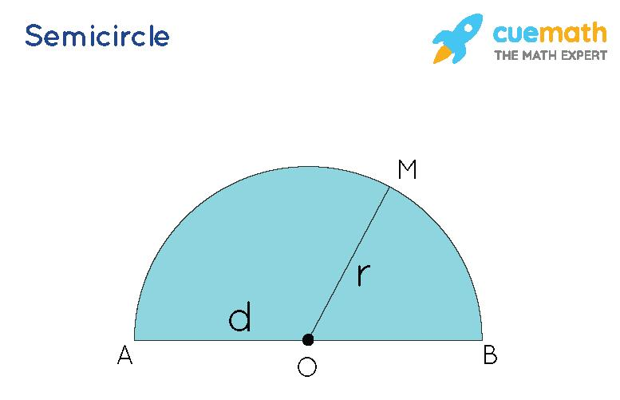
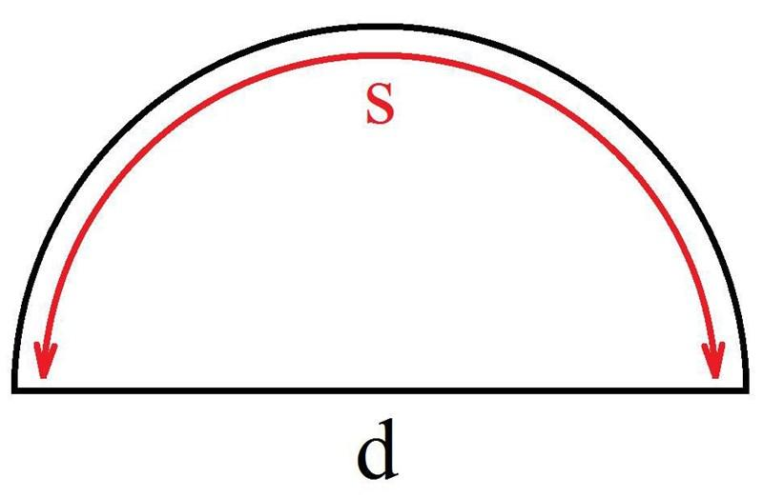
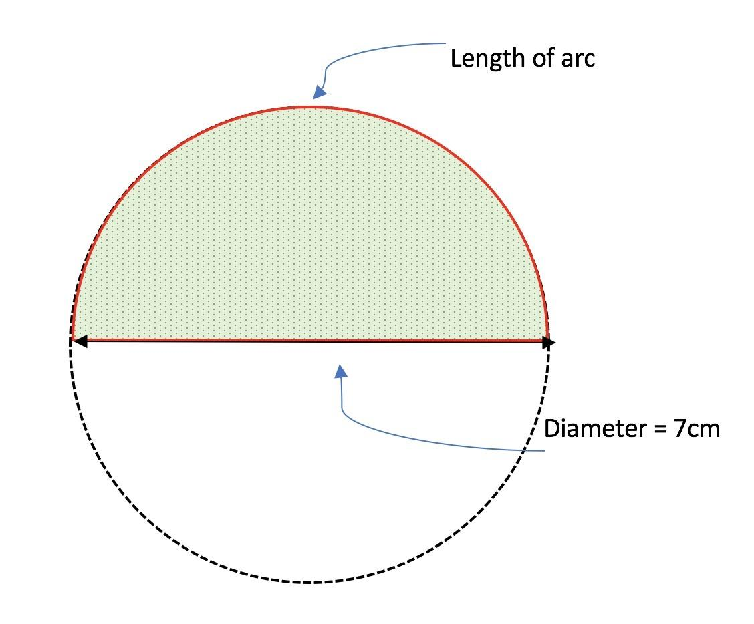
It is important to distinguish:
- Semicircular arc → the curved half of the circumference.
- Diameter → the straight segment connecting the endpoints.
- Semicircle → the region bounded by the semicircular arc and the diameter.

Semicircular Arc and Central Angle
# Source: AI Source: Provided by: [Data Path: Persons Table -> ID Column: 1, Name_En Column: Motasem Essam] -> From: [ChatGPT] on [7/25/2026]
The central angle corresponding to a semicircular arc is a straight angle:
$$m\left(∠AOB\right)={180}^{∘}$$
Therefore:
$$\boxed{m\left(\hat{AB}\right)=m\left(∠AOB\right)={180}^{∘}}$$

Semicircular Arc and Inscribed Angle
# Source: AI Source: Provided by: [Data Path: Persons Table -> ID Column: 1, Name_En Column: Motasem Essam] -> From: [ChatGPT] on [7/25/2026]
An angle inscribed in a semicircle is a right angle.
This is known as Thales' theorem.
If $AB$is a diameter and $C$is any point on the circle:
$$\boxed{m\left(∠ACB\right)={90}^{∘}}$$
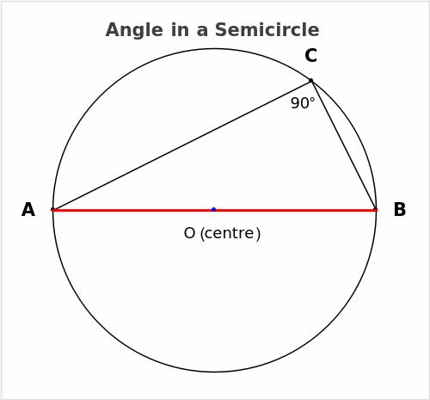
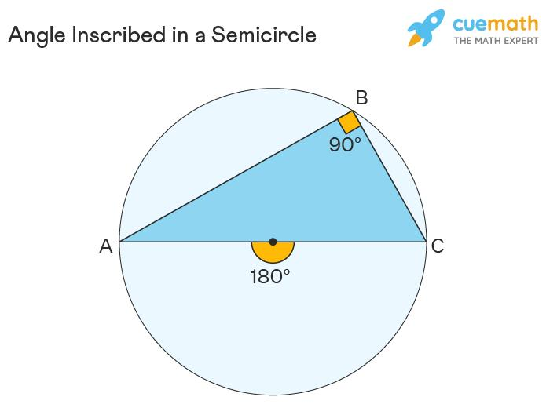
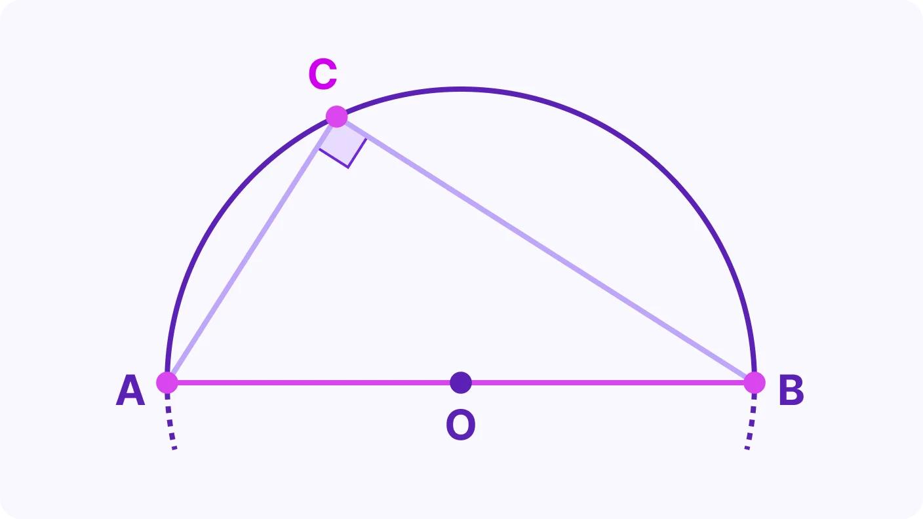
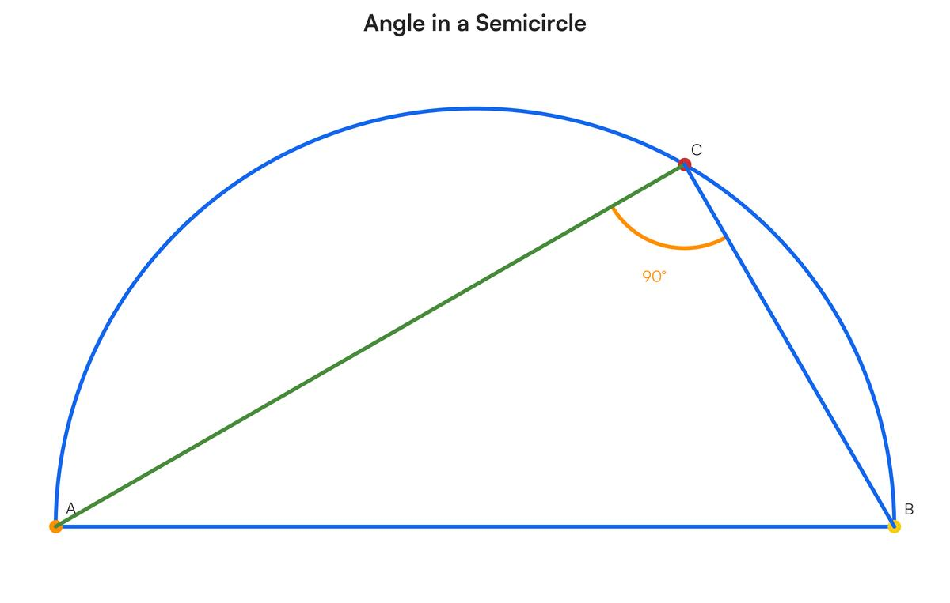
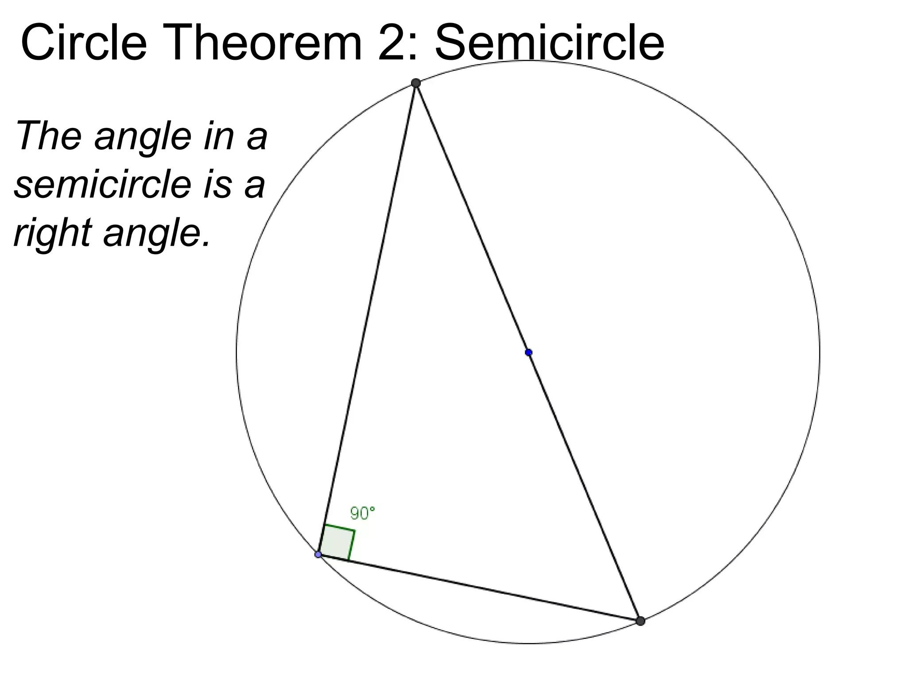

Semicircular Arc vs. Minor Arc vs. Major Arc
# Source: AI Source: Provided by: [Data Path: Persons Table -> ID Column: 1, Name_En Column: Motasem Essam] -> From: [ChatGPT] on [7/25/2026]
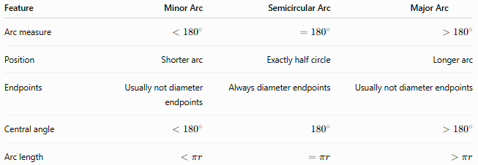
Feature | Minor Arc | Semicircular Arc | Major Arc
Arc measure | $$<{180}^{∘}$$ | $$={180}^{∘}$$ | $$>{180}^{∘}$$
Position | Shorter arc | Exactly half circle | Longer arc
Endpoints | Usually not diameter endpoints | Always diameter endpoints | Usually not diameter endpoints
Central angle | $$<{180}^{∘}$$ | $${180}^{∘}$$ | $$>{180}^{∘}$$
Arc length | $$<πr$$ | $$=πr$$ | $$>πr$$

Naming a Semicircular Arc
# Source: AI Source: Provided by: [Data Path: Persons Table -> ID Column: 1, Name_En Column: Motasem Essam] -> From: [ChatGPT] on [7/25/2026]
A semicircular arc can be identified by the two endpoints of its diameter, but because two semicircular arcs exist between those endpoints, three-letter notation is often used to specify which half is intended.
For example:
$$\hat{ACB}$$
means the semicircular arc from $A$to $B$passing through $C$.
Similarly:
$$\hat{ADB}$$
can identify the other semicircular arc.

Classification
# Source: AI Source: Provided by: [Data Path: Persons Table -> ID Column: 1, Name_En Column: Motasem Essam] -> From: [ChatGPT] on [7/25/2026]
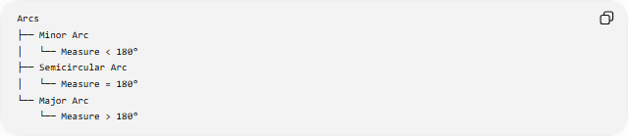
Arcs
├── Minor Arc
│ └── Measure < 180°
├── Semicircular Arc
│ └── Measure = 180°
└── Major Arc
└── Measure > 180°
More specifically:
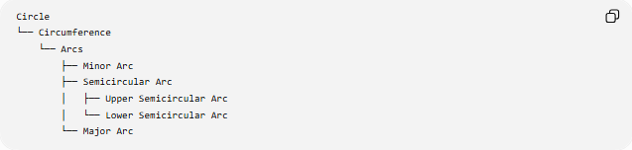
Circle
└── Circumference
└── Arcs
├── Minor Arc
├── Semicircular Arc
│ ├── Upper Semicircular Arc
│ └── Lower Semicircular Arc
└── Major Arc

Key Points
# Source: AI Source: Provided by: [Data Path: Persons Table -> ID Column: 1, Name_En Column: Motasem Essam] -> From: [ChatGPT] on [7/25/2026]
- A Semicircular Arc measures exactly ${180}^{∘}$.
- It is exactly half of a circle's circumference.
- Its endpoints are the endpoints of a diameter.
- Its arc length is:
$$\boxed{L=πr}$$
- Its corresponding central angle is ${180}^{∘}$.
- An angle subtended by a diameter at the circumference is ${90}^{∘}$.
- Two semicircular arcs together make the complete circumference:
$${180}^{∘}+{180}^{∘}={360}^{∘}$$

Conclusion
# Source: AI Source: Provided by: [Data Path: Persons Table -> ID Column: 1, Name_En Column: Motasem Essam] -> From: [ChatGPT] on [7/25/2026]
A Semicircular Arc is an arc measuring exactly ${180}^{∘}$, formed by the endpoints of a diameter. It represents one-half of the circumference and has an arc length of $πr$. It is the boundary component of a semicircle and is distinguished from a minor arc by its exact ${180}^{∘}$ measure and from a major arc by its shorter, half-circle extent.

